Retrofit Kit Instillation
Manual
2020 Precedent Electric Golf Car

Table of Contents

- Introduction Page 4
  - 1.1 Purpose of the Retrofit Kit Instruction Manual ( 4 )
  - 1.2 Scope of Work ( 4 ) Page 4
- Tools Required to Remove All Parts Page 5
  - 2.1 Hand Tools ( 5 )
  - 2.2 Wrenches & Sockets ( 5 )
  - 2.3 Safety Equipment ( 5 )
- Safety Precautions Page 6
  - 3.1 Before You Touch Anything ( 6 )
- Disconnecting the Batteries Page 6
- Canopy/Roof Removal Page 7
- Wire Routing Page 8-10
- Solar Mount Installation Page 10-12
- Installing the Solar Panel Page 12-14
  - 8.1 Preparing the Mount ( 12 )
  - 8.2 Preparing the Gasket ( 13 )
  - 8.3 Installing the Solar Panel ( 13 )
  - 8.4 Securing the Solar Panel ( 14 )
- Battery Installation Page 15-17
  - 9.1 Preparing the Battery Installation ( 15 )
  - 9.2 Installing the Charging Port ( 16 )
  - 9.3 Mounting the Battery, Metal Plate, and Converter ( 16 )
  - 9.4 Connecting the System ( 17 )
List of Figures (optional, goes right after the TOC)
- Figure 1: Vehicle with Removed Roof
- Figure 2: Holding Brackets Removed from Vehicle
- Figures 3 and 4: Wire Frame Disconnection
- Figure 5: Drill Hole in Wheel Well
- Figures 6 and 7: Front and Rear Frame Attached
- Figure 8: Installed Solar Panel Frame
- Figure 9: Rubber Lining
- Figure 10: Cover Plate Installed
- Figures 11 and 12: Battery Compartment Before
- Figures 13 and 14: Plastic Cut for a Smooth Surface
- Figure 15: Installation of the Battery and Controller

1. Introduction
  - Purpose of the Retrofit Kit Instruction Manual
The purpose of this instruction manual is to help you complete the conversion of your golf car and turn it into a fully reliable solar powered golf car.

  - Scope of Work
The scope covers the following planned modifications and installations:
- Removal and replacement of the existing battery system
- Removal of the existing roof structure and installation of the new roof assembly
- Restoration and organization of the vehicles electrical system

2. Tools Required to Remove All Parts

2.1 Hand Tools
- Flathead screwdriver (small, medium, large)
- Phillips head screwdriver (#1, #2)
- 2 crescent wrenches
- Drill
2.2 Wrenches & Sockets

2.3 Safety Equipment
- Safety glasses

3. Warning: Improper battery removal can cause serious injury, electrical shock, or damage to the equipment. Read all the cautions below before proceeding.

⚠️3.1 Before you touch anything ⚠️

- Place the TOW/RUN switch in the TOW position before disconnecting or connecting batteries- failure to do so could result in battery explosion or severe personal injury.
- Turn the key switch to the OFF position and remove the key
- Place the Forward/Reverse handle in the Neutral position
- Set the park brake and chock the wheels
- Use only insulated tools near batteries and electrical connections
- Do not wear loose clothing, rings, watches, or chains while working near batteries
- Use extreme caution to avoid shorting components or wiring

4. Disconnecting the batteries
Tools Required
- Insulated 5/8" socket and ratchet
- Torque wrench
⚠️ WARNING: Place the Tow/Run switch in the TOW position before disconnecting or connecting batteries. Failure to do so could result in a battery explosion or severe personal injury.
- Disable the vehicle per the steps in Section X.
- Place the Tow/Run switch in the TOW position.
- Disconnect the negative (–) cable first.
- Wait 90 seconds for the controller capacitors to fully discharge before proceeding.
- Remove the battery hold-down nuts using a 5/8" socket.
💡 NOTE: Terminal wrench size will vary depending on battery type installed. Confirm size before beginning.

5. Canopy/Roof removal
Tools Required
- Two combination wrenches (crescent wrenches)
- Socket wrench — rear support bolts (see note)
NOTE: Need to add in socket size in
Steps:
- Remove the two nuts and two bolts from the canopy at each front canopy support.
- Remove the nuts and bolts from the canopy at the rear support.
- Lift the canopy away from the front and rear supports and set aside in a safe location. Make sure there is plenty of flat space.
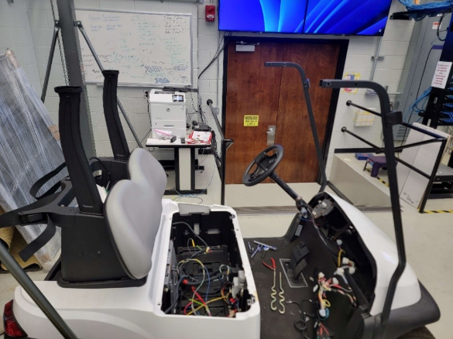
Figure 1 – Vehicle with Removed Roof

6. Wire Routing
Tools Required
- Electric drill
- Appropriate drill bit for wire grommet size
- Fish wire or pull string
- Grommet
Steps:
- Remove the rear roof holding brackets.
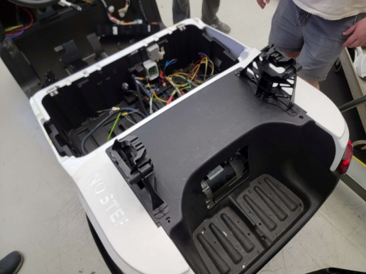
Figure 2. Holding Brackets Removed from Vehicle

- Disconnect the solar panel wiring from the mount. This will make the mount easier to handle during installation and allow the wires to be routed separately.
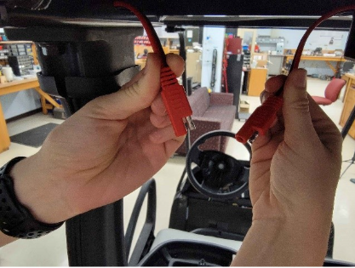
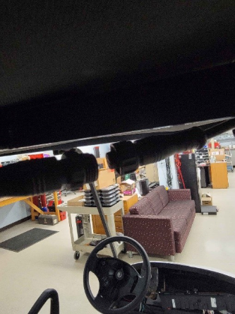
Figure 3 and 4. Wire frame disconnection
- Feed a pull string or fish wire through the rear canopy supports from top to bottom. This will be used to pull the solar wiring through the supports in the following steps.
- Attach the solar panel wiring to the pull string and carefully pull the wiring down through the rear canopy supports.
- Route the wiring from the bottom of the rear supports down into the wheel well. Then reattach the holding brackets so the wiring comes out of both sides.
- Select a suitable location in the wheel well to drill through. Ensure the chosen location avoids any existing wiring, structural components, or hardware behind the drill point before proceeding.
- Drill the hole at the selected location and then run the wire into the battery compartment. ( approximately 1-1.5 inch hole) You will need to do this in both rear wells.
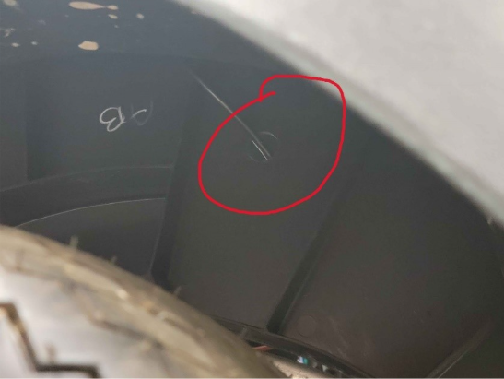
Figure 5. Drill hole in Wheel Well

7. Solar Mount installation

Tools Required
- Socket wrench – (size)
- Drill and Spade bit
💡 NOTE: The solar mount kit includes all necessary mounting hardware. Do not substitute with other bolts as the provided hardware is sized specifically for this installation. During installation, the rear supports may spread slightly to align with the mounting holes. This is normal and expected. You will need two people to do this part.
Steps:
- Place the front spacer over the front canopy support mounting holes on both the driver side and passenger side. Confirm that all holes are aligned with the factory mount locations before proceeding.
- Position the solar mount frame onto the front and rear canopy supports. Verify that all mounting holes line up with the factory hole locations before installing any hardware.
- Insert the provided bolts through the solar mount and front spacer into the front canopy support holes. Hand tightens only at this time.
- Insert the provided bolts through the solar mount into the rear canopy support holes. Hand tightens only at this time.
- Once all bolts are hand tight and the mount is properly aligned, tighten the front bolts.
- Tighten the rear bolts.
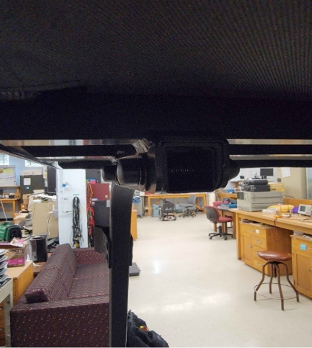

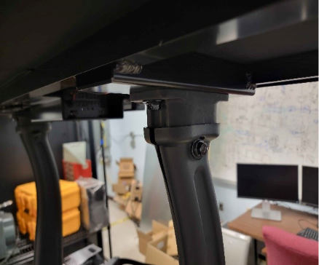
Figure 6 and 7. Front and rear frame attached.

- Visually inspect all mounting points to confirm the solar mount is secure and level before installing the solar panel.
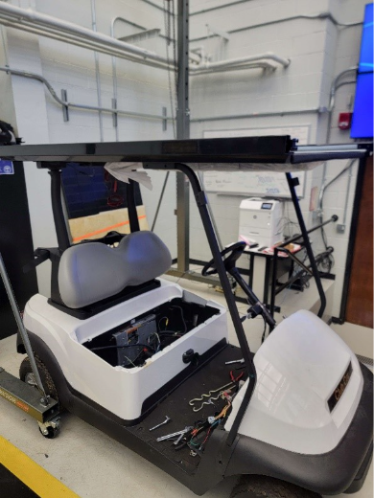
Figure 8. Installed Solar Panel Frame

8. Installing the Solar panel
Tools Required
- Screwdriver
- Scissor or utility knife

8.1 Preparing the Mount
- Remove the four screws from the front and rear of the solar mount and set aside. These screws will be reused to secure the cover pieces in a later step.

8.2 Preparing the Gasket
- Cut the rubber gasket in half using scissors or a utility knife.
- Place one half of the gasket along the front of the solar panel and the other half along the back of the solar panel where the panel will rest.
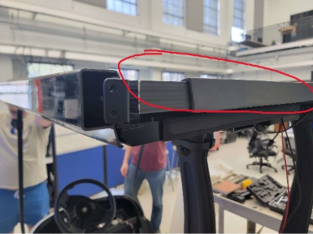
Figure 9. Rubber Lining
💡 NOTE: The rubber gasket protects the solar panel from vibration damage and ensures it lies flat with no bunching or gaps before placing the panel.
8.3 Installing the Solar Panel
- Orient the solar panel so that the positive (+) and negative (–) wires exit from the rear of the panel toward the rear of the mount.

- Carefully lower the solar panel onto the mount, seating it onto the front and rear gaskets
- Connect the positive (+) wire from the solar panel to the corresponding positive connection on the rear of the solar mount.
- Connect the negative (–) wire from the solar panel to the corresponding negative connection on the rear of the solar mount.
⚠️ CAUTION: Ensure the positive and negative wires are connected to their correct terminals. Reversing polarity could result in damage to the electrical system.
8.4 Securing the Solar Panel
- Position the front cover piece over the front edge of the solar panel.
- Position the rear cover piece over the rear edge of the solar panel.
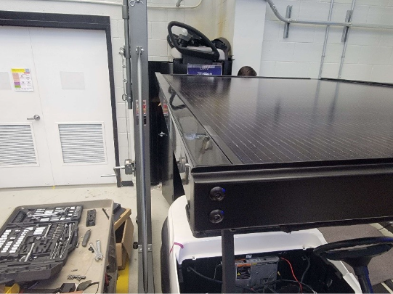
Figure 10. Cover Plate Installed
- Secure both cover pieces using the screws removed in Step 1. Tighten screws evenly, alternating sides, until the solar panel is held firmly in place with no movement.
💡 NOTE: Do not overtighten the cover screws. The panel should be held securely but the screws should not compress the gasket excessively as this could crack the panel frame.

9. Battery Installation

9.1 Preparing the Battery Installation
1. Clean the battery compartment. Vacuum out any debris and clean up any acid left from a faulty or old battery.
2. Remove the raised pieces so the battery sits level on the floor. Use a power tool to remove them.
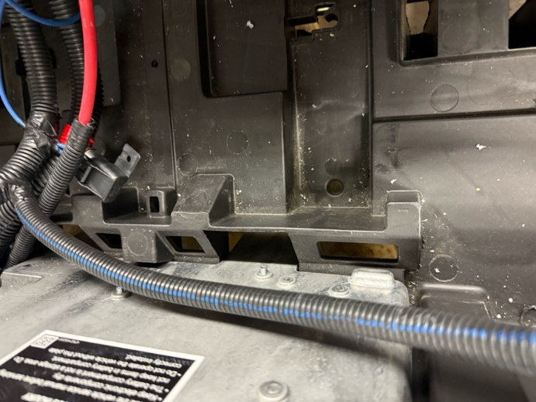
Figure 11 and 12. What the compartment looks like before
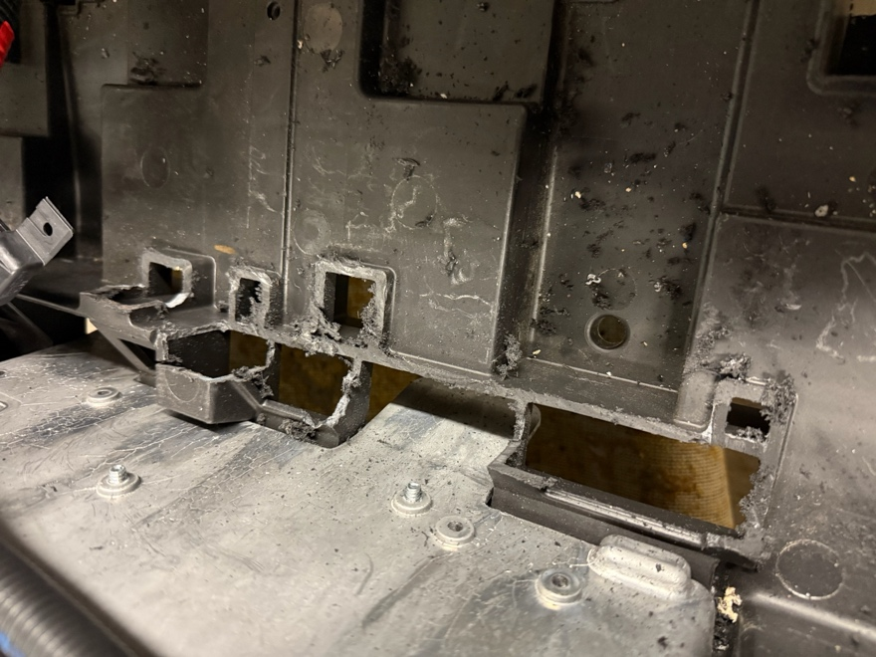
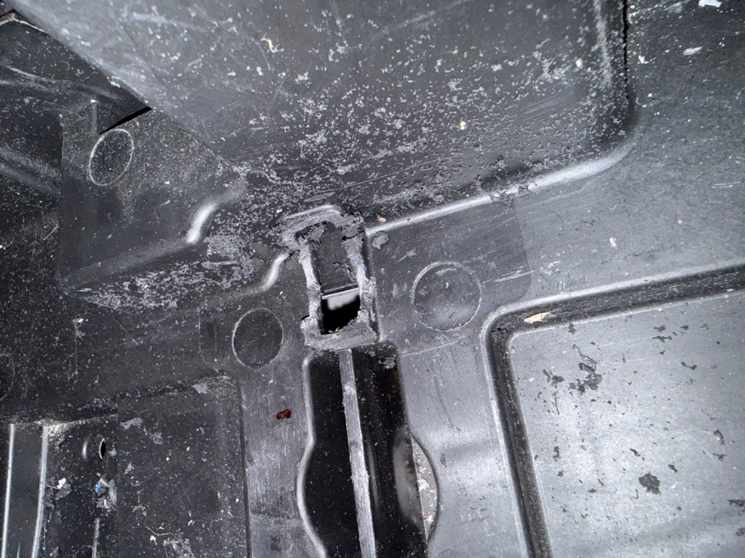
Figure 13 and 14. The Plastic cut for a smooth surface
9.2 Running the Wiring
3. Run the start button and battery display wiring from the console to the battery compartment. Feed the end with exposed wires through one of the holes underneath the plastic exterior.
💡 NOTE: Route the wires under the mat so they will not be crushed over time.
9.3 Replacing the Charging Port
4. Remove the old charging port from the golf car. You can either tuck it away inside the compartment once the battery is installed or disconnect it from the cart.
5. Install the new charging port. One end has a cover and a port for the outlet. The other end connects to the converter.
6. Feed the converter end through the hole where the old charging port was.
7. Drill holes in the plastic to mount the new charging port. ( It should go on the driver side of the cart because the battery will go on the passenger side.)

9.4 Mounting the Battery, Metal Plate, and Converter
8. Set the battery in place with its mounting brackets and mark where the screw holes will go.

9. Set the metal plate beside the battery. Make sure there is enough space and that no wires will be pinched.
10. Mark and drill the holes for both the battery and the metal plate.
11. Pull the metal plate out and install the battery screws.
12. Put the metal plate back and mount it to the floor.
13. Place the converter on the metal plate and mount it.
Connecting the System
1. Connect the charger outlet to the converter.
2. Connect the converter and battery to the solar panel.
3. Connect the start button, battery display, and the golf car’s positive and negative terminals to the battery.
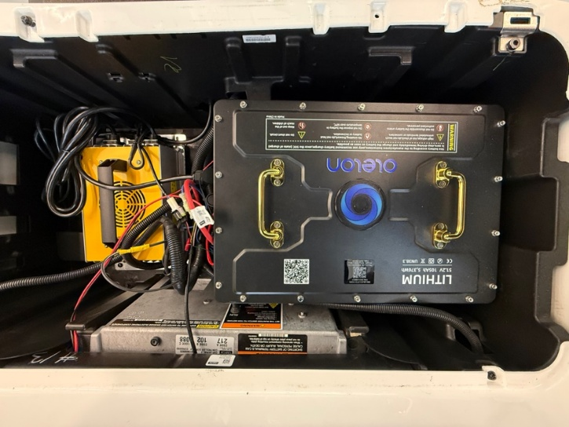
Figure 15. Installation of the Battery and Controller
⚠️ CAUTION: Confirm all polarity before connecting. (My addition, to match your solar panel caution.)

